10.96: The initial angular momentum is 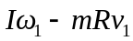, with the minus sign indicating that runner’s motion is opposite the motion of the part of the turntable under his feet. The final angular momentum is 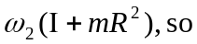
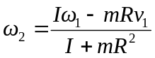

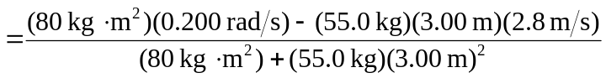
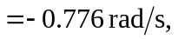

where the minus sign indicates that the turntable has reversed its direction of motion (i.e., the man had the larger magnitude of angular momentum initially).

